**A level 1B**

In this model the subject ID is the combination of the number of the subject and the subject name.

**B) Level 1**

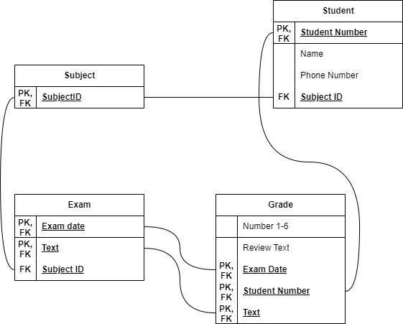

Here the grade consists of the combination of the student number exam date and text to uniquely identify it as a composite table.  
  
**Part 2: Dimensional modelling (LEVEL 1)**

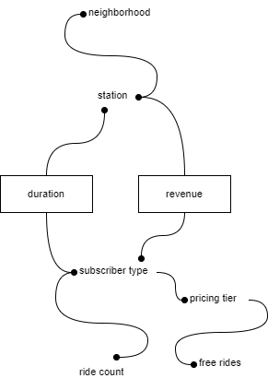This model only uses duration and revenue as facts as those are the only two relevant facts I interpreted from the description. The rest are the dimensions that are useful for the customer, where you look up the station and neighbourhood to find specific revenue and duration. While in the other dimension you look up the subscriber type as well as the other related dimensions to the fact that these dimensions holds. Like how many rides a specific rider type uses as well as their pricing tier combined with free rides. AS I think it would be most useful to look at free rides in comparison to their pricing tier via the subscriber type. While as the more useful information for revenue can be found on the station itself as well as the neighbourhood.